**University of engineering & technology Peshawar**



**COMPUTER PROGRAMMING -LAB**

**Lab report # 3**

**Fall 2020**

**Submitted by: Ashfaq Ahmad**

**Section: B**

**Reg No: 19PWCSE1795**

**Semester: 2nd**

**Submitted to:**

**Eng: Abdullah**

**Department Of Computer System Engineering**

## Objectives:

* To be familiar with Relational & Logical Operators
* To understand the programming knowledge using Decision Statements (if, if-else, if-else ladder, Nested if-else)
* **Task 1:** Display the largest among three numbers using if else statement?

**Souce code:**

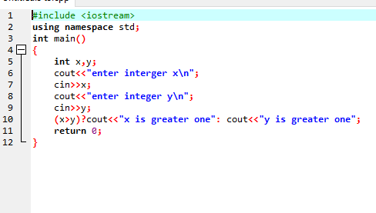

**Compilation:**

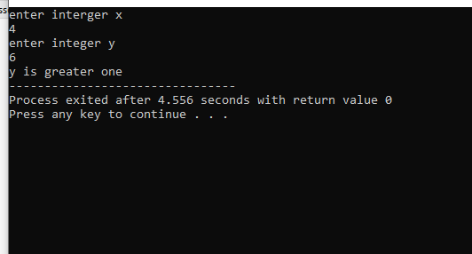

* **Task 2:** Check whether a number is even or odd?

**Source code:**

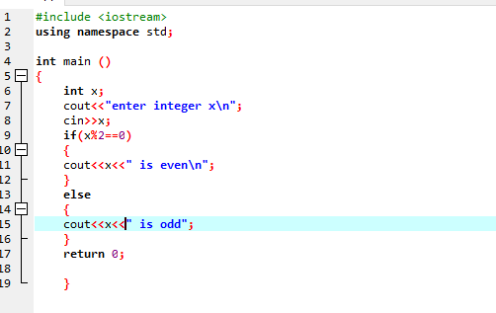

**Compilation:**

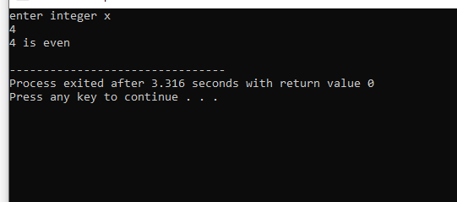

* **Task 3:**

Check the greater of two numbers using ternary operator?

**Source code:**

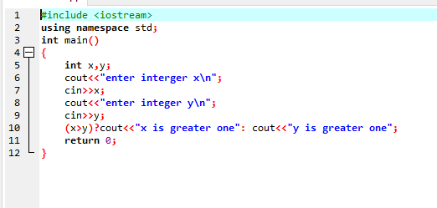

**Compilation:**

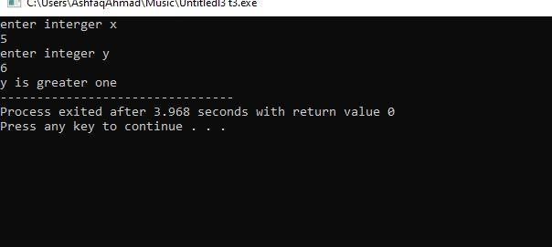

* **Task 4:**

Write a Marks Sheet program, input 3 subject marks from user and show data on screen, with percentage, grade (Assume total marks = 100).

**Source code:**

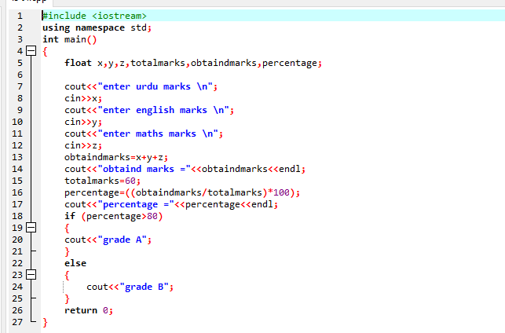

**Compilation:**

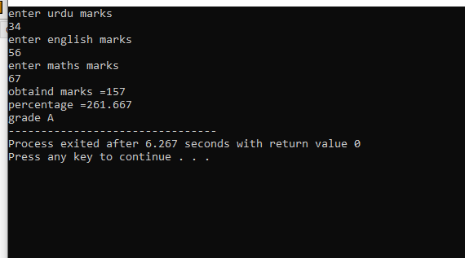

* **Task 5:**

Write a C++ program that takes two operands and one operator from the user, the program should implement basic arithmetic operations – sum, average, product, difference, quotient, remainder, and, or and not of given numbers etc.

**Source code:**

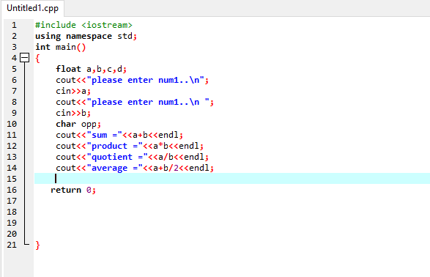

**Compilation:**

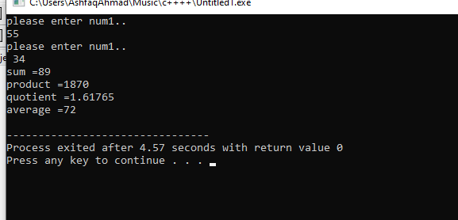

* **Task 6:**

Write a program that asks a number and test the number whether it is multiple of 5 or not, divisible by 7 but not by eleven. (All three conditions should match)

**Source code:**

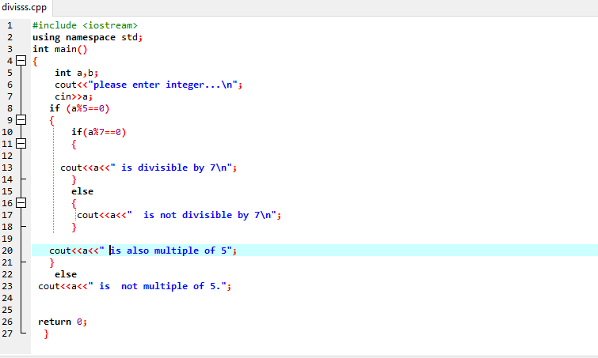

**Compilation:**

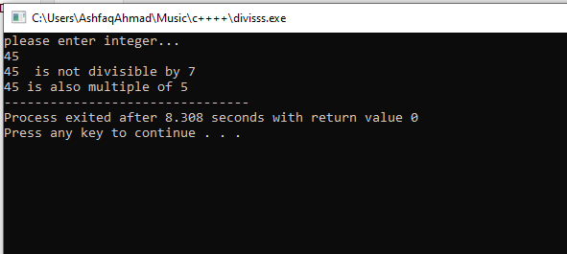

* **Task: 7**

Check whether the entered character is vowel or consonant?

**Source code:**

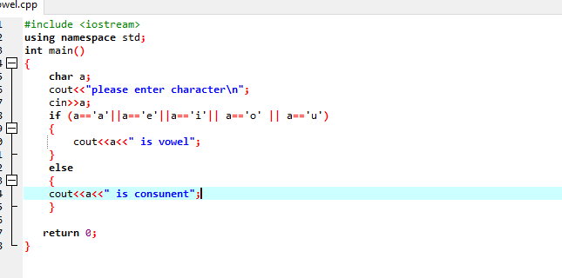

**Compilation:**

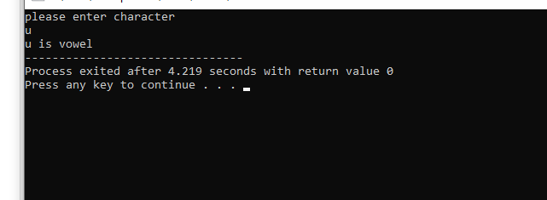

* **Task 8:**

Write a program that takes the week day number as input from user and print the day name of week

**Source code:**

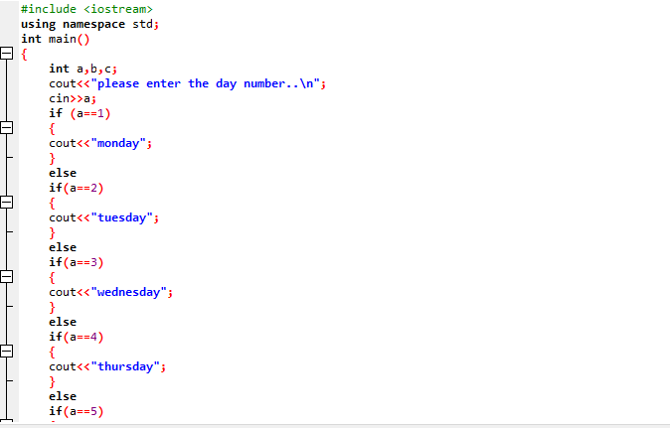

**Compilation:**

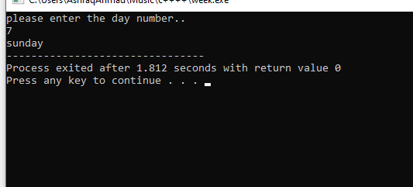

* **Task no 9:**

Write a C++ program to enter month number between (1-12) and print number of days in month.

**Source code:**

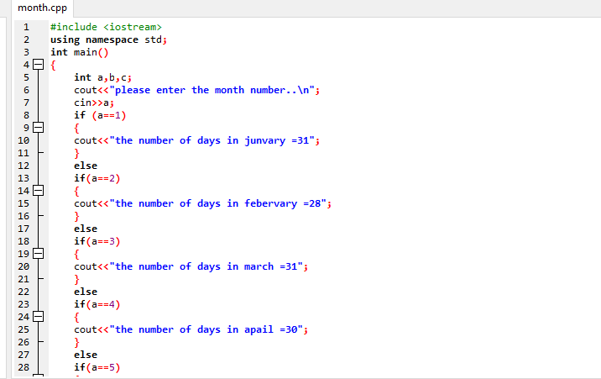

**Compilation:**

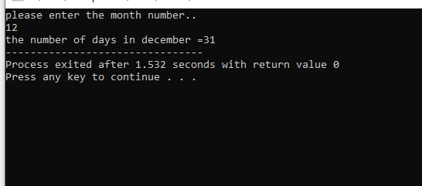

* **Task no 10:**

Write a program to calculate and print the Electricity bill of a given customer. The customer id and unit consumed by the user should be taken from the keyboard and display the total amount to pay to the customer. The charges are as follow :

|  |  |
| --- | --- |
| **Unit** | **Charge/unit** |
| upto 199 | @1.20 |
| 200 and above but less than 400 | @1.50 |
| 400 and above but less than 600 | @1.80 |
| 600 and above | @2.00 |

If bill exceeds Rs. 400 then a surcharge of 15% will be charged and the minimum bill should be of Rs. 100/-

**Source code:**

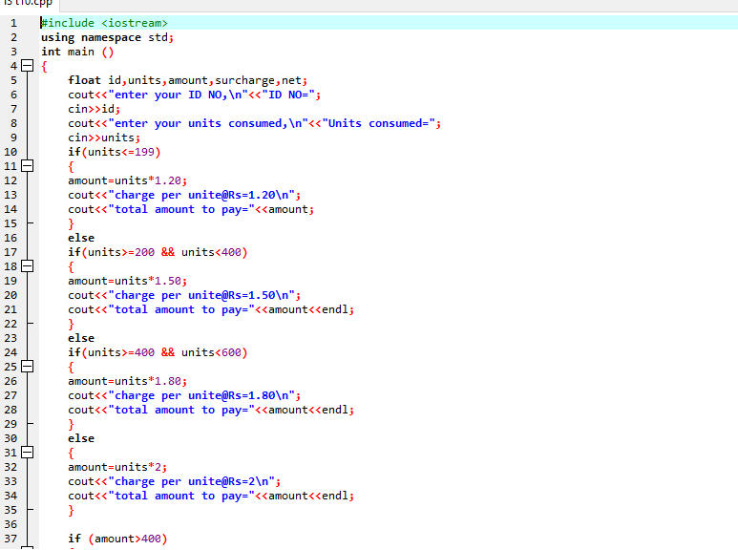

**Compilation:**

